Research Question: Which pathways are affected by induction with methyl jasmonate?

M:

Check read quality

Check if reads are trimmed properly

Genome Mapping with Hisat2

Transcriptome identification with cufflinks

Gene annotation with

S:

Predict biosynthetic pathway gene clusters using Plantismash with genomes V1 and V2

C:

Compare additional samples

Compare status of different samples with different inducement

find out technical and biological variation

W:

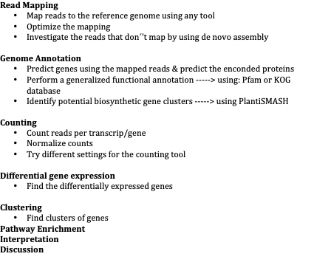

differential: control vs meja

pathway enrichment for DFG

annotate pathways (kegg, GO, blastkoala (kegg orthology groups), egg-nog (cog), cathacyc (gene ID’s from transcriptome from 2012, needs conversion))

probably transcriptome, smaller (2015, 2018)

either use paper settings or use own version and compare (which samples)

find meja treatment samples from cathacyc paper

effect gone after 24 hours, so compare multiple timestamps (0,6 - 6,12 - 0,24 etc)

include ethylene treatment